*SYSINTERNALS SUITE*

[AccessEnum](https://docs.microsoft.com/en-us/sysinternals/downloads/accessenum) - Shows you who has what access to directories, files etc

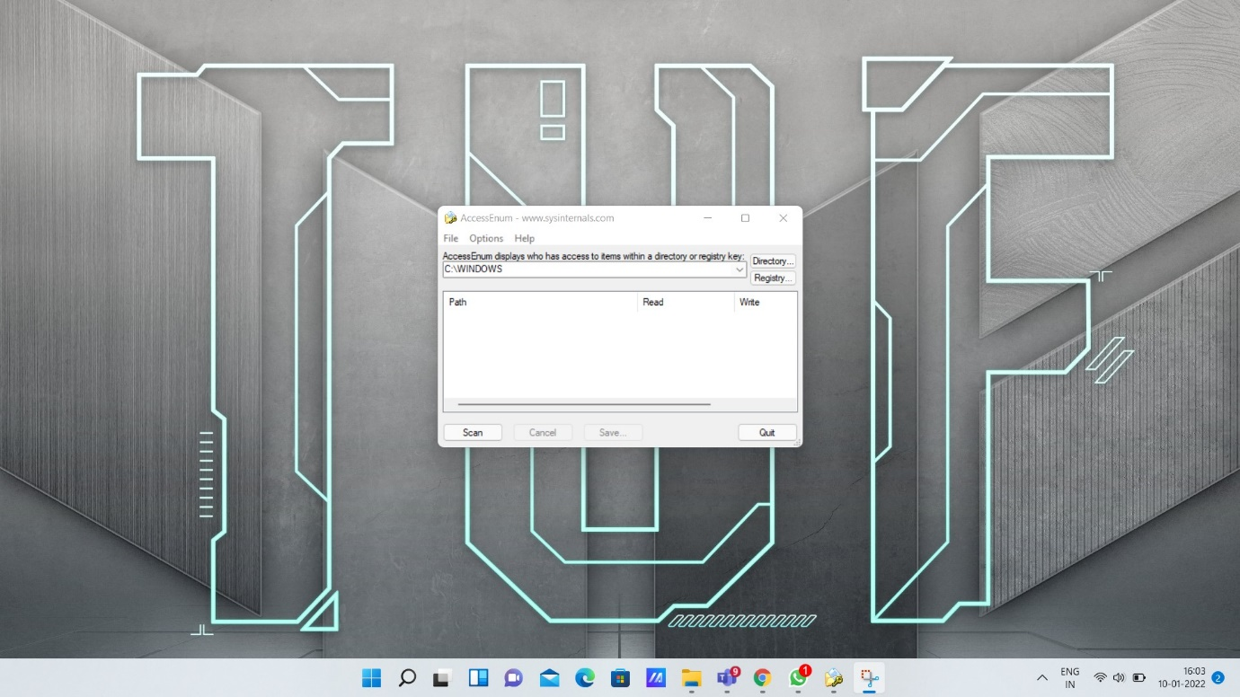

[AdExplorer](https://docs.microsoft.com/en-us/sysinternals/downloads/adexplorer) - Advanced Active Directory (AD) viewer and editor.

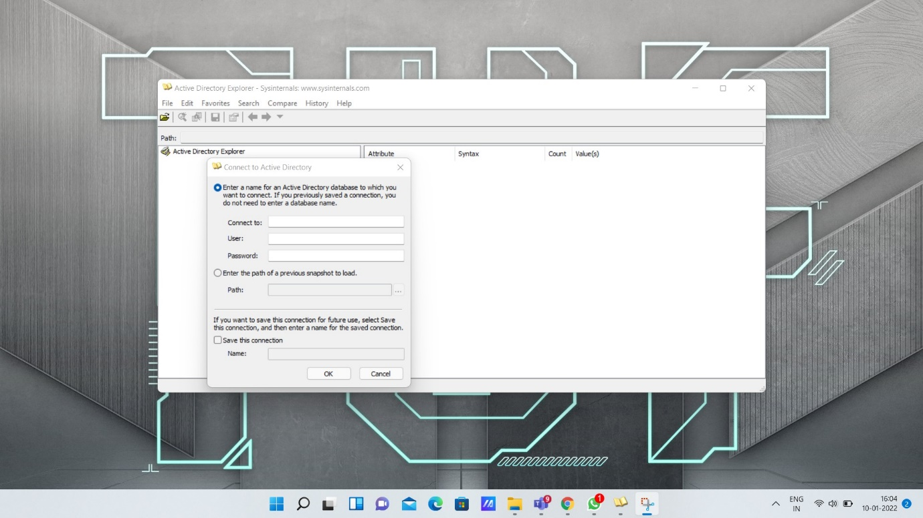

[AdInsight](https://docs.microsoft.com/en-us/sysinternals/downloads/adinsight) - A real-time monitoring tool aimed at troubleshooting applications.

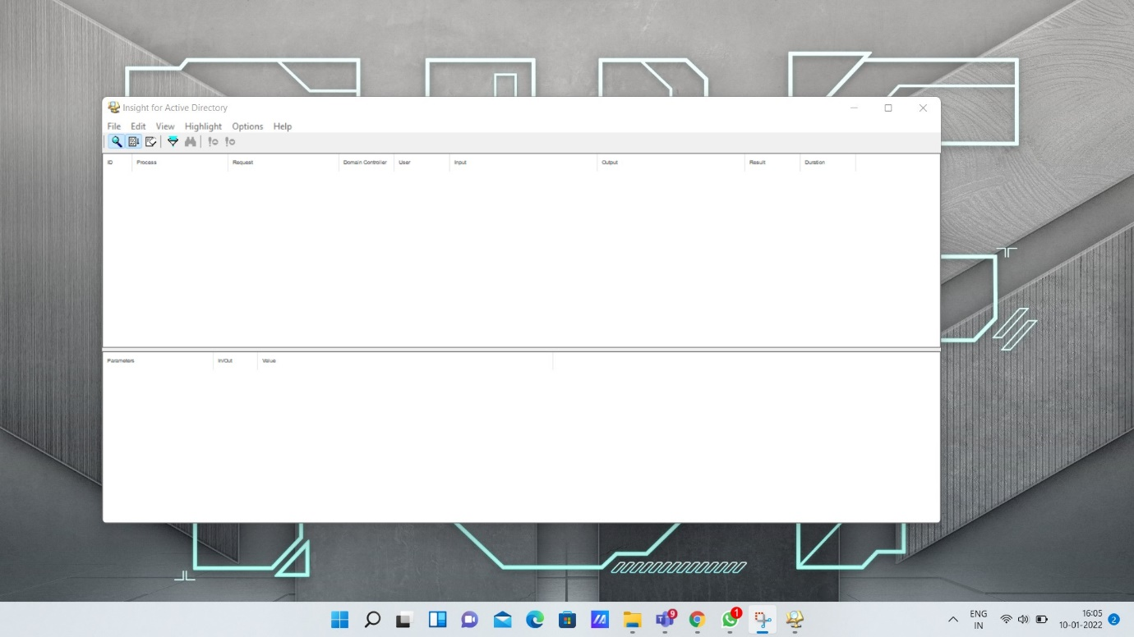

Adrestore - Displays the deleted objects in a domain

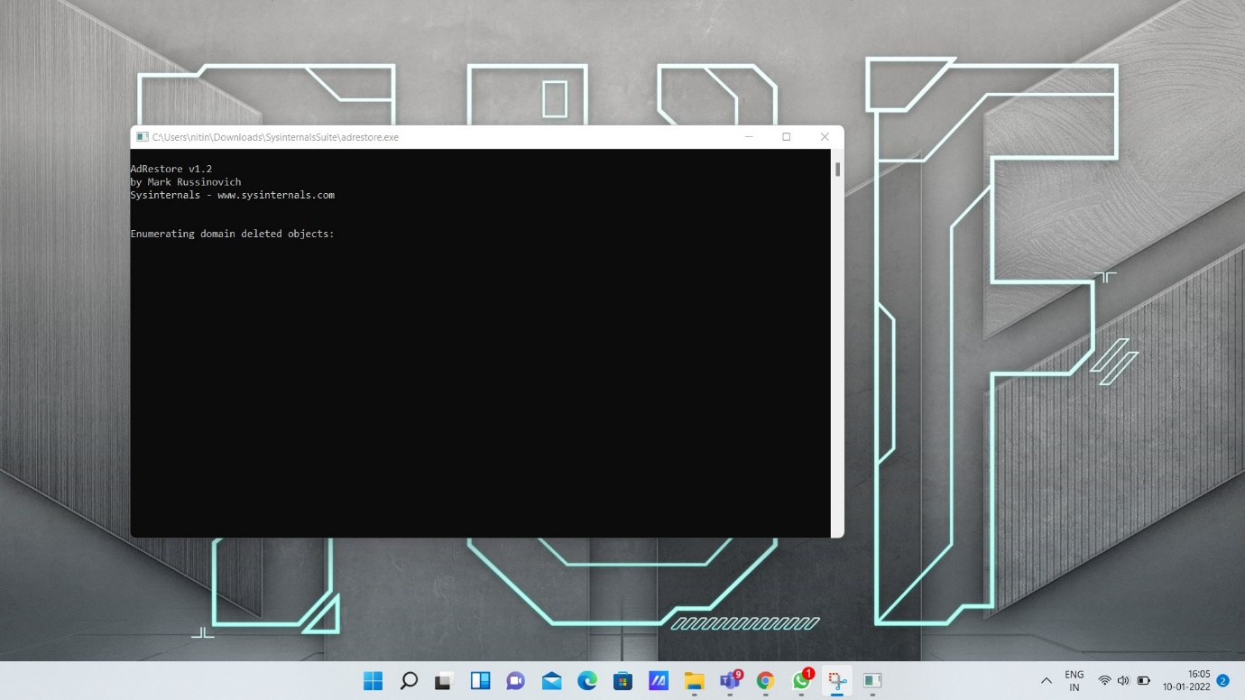

[Autologon](https://docs.microsoft.com/en-us/sysinternals/downloads/autologon) - Bypass password screen during logon.

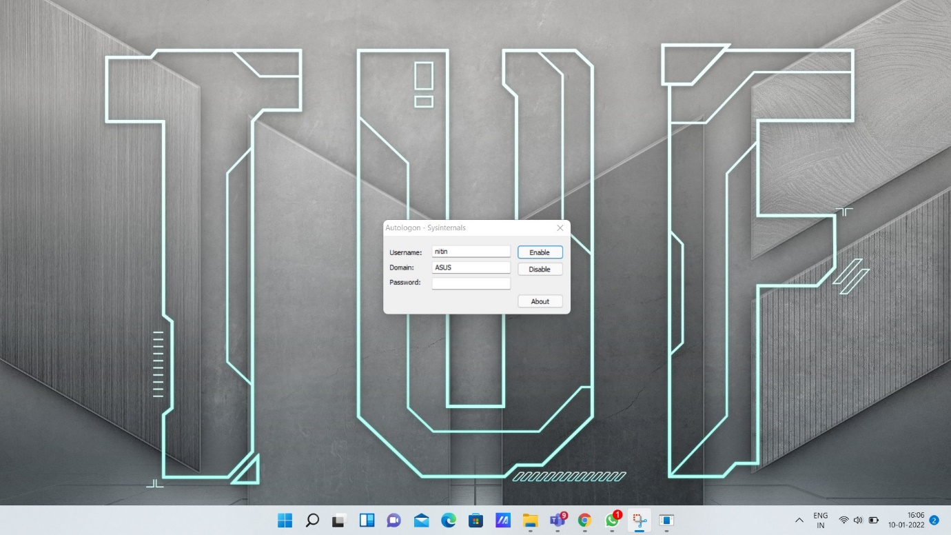

[Autoruns](https://docs.microsoft.com/en-us/sysinternals/downloads/autoruns) - Display programs that are configured to startup automatically when your system boots and you login.

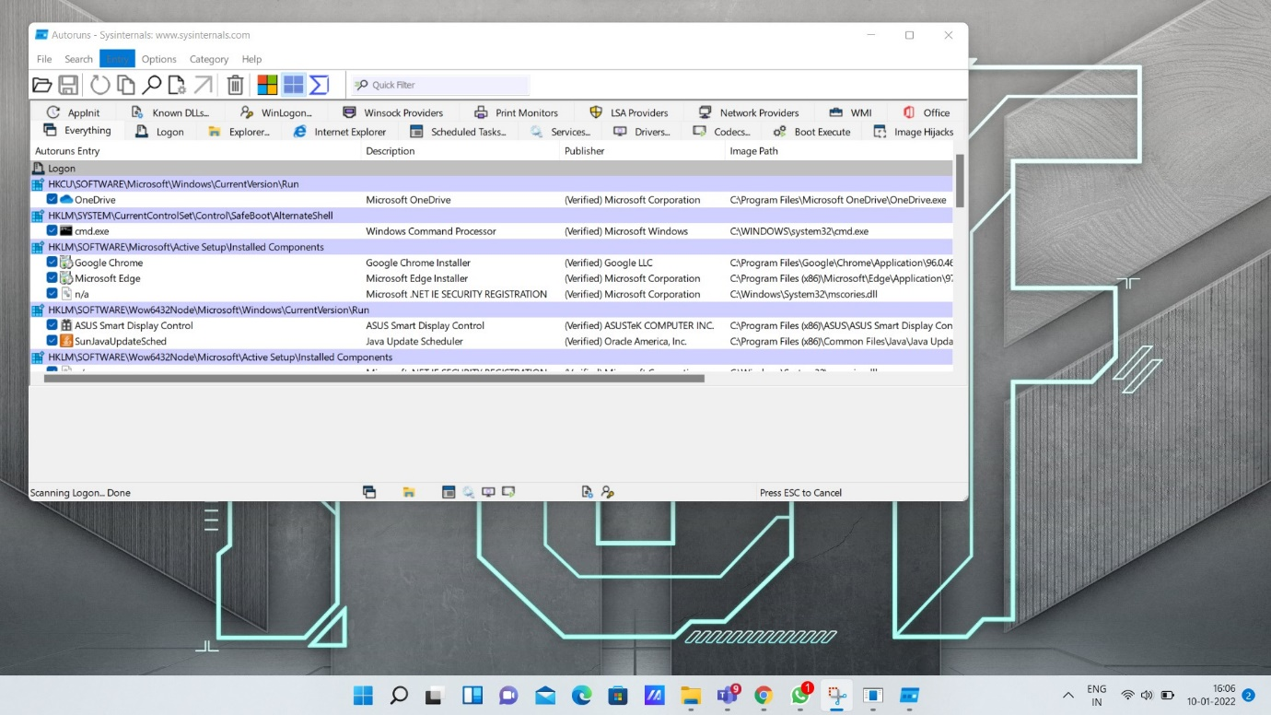

[BgInfo](https://docs.microsoft.com/en-us/sysinternals/downloads/bginfo) - Display info about the system including IP addresses, computer name, network adapters, and more.

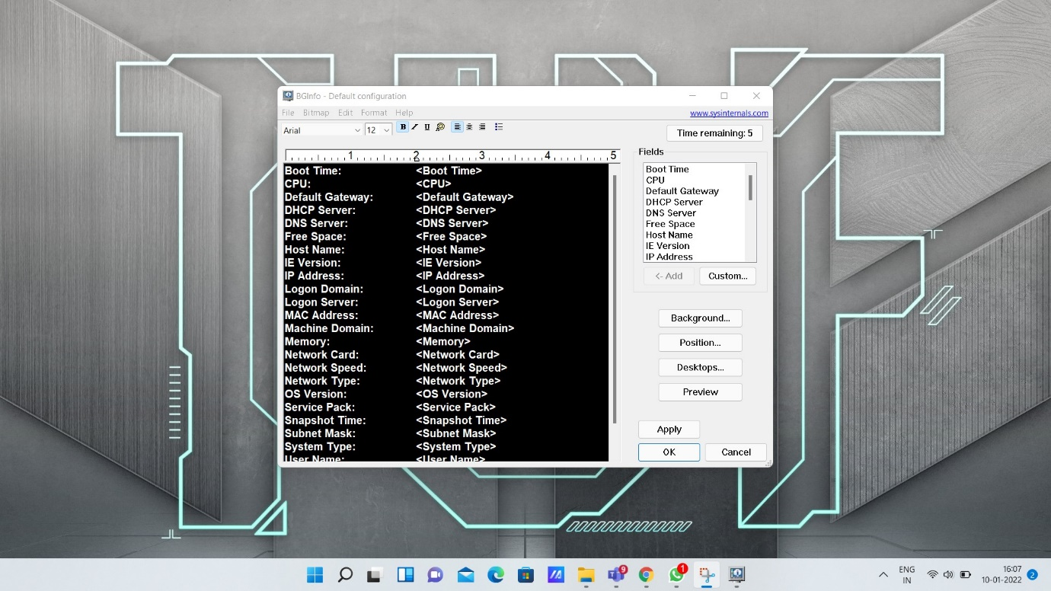

CPU stress - Used to simulate CPU activity

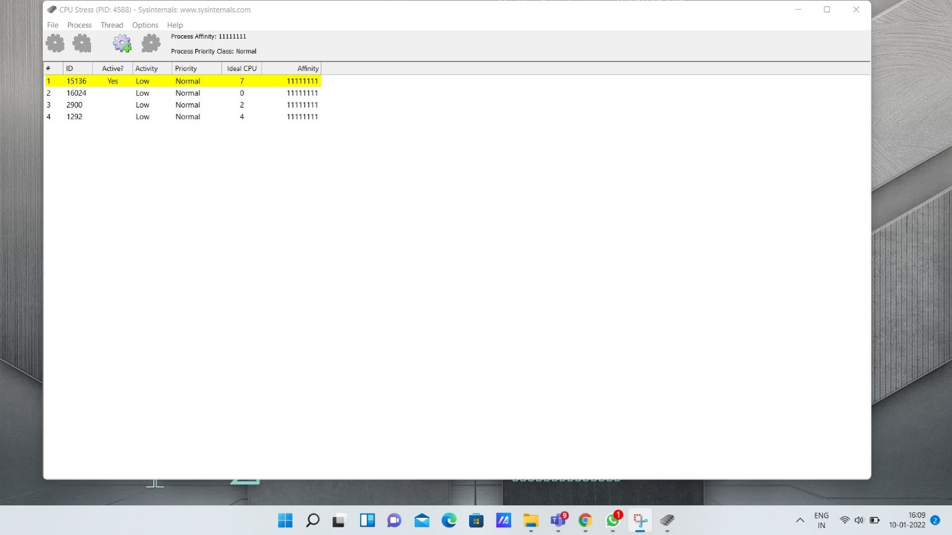

[DebugView](https://docs.microsoft.com/en-us/sysinternals/downloads/debugview) - Helps for viewing and recording of debug session on your local machine.

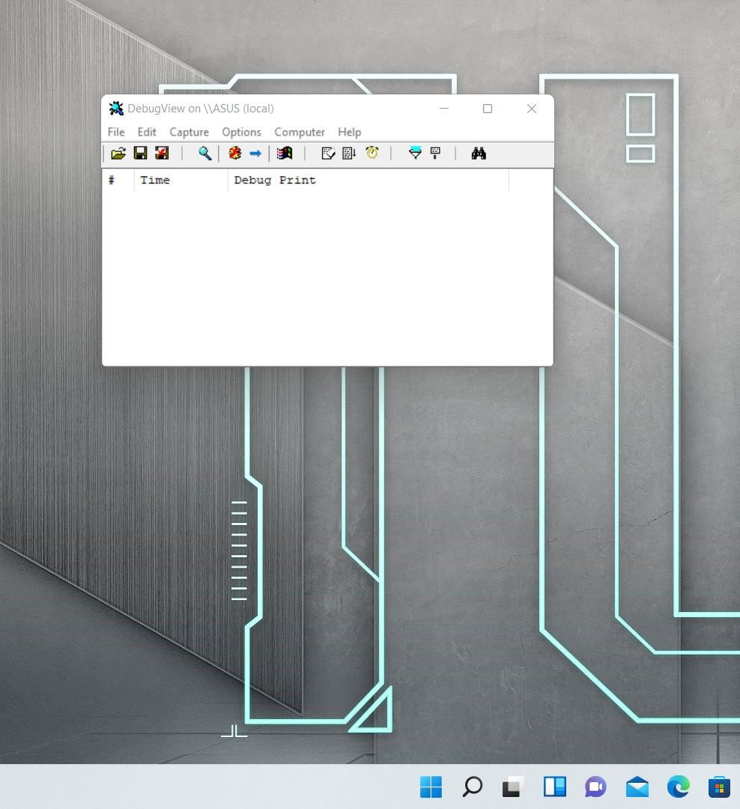

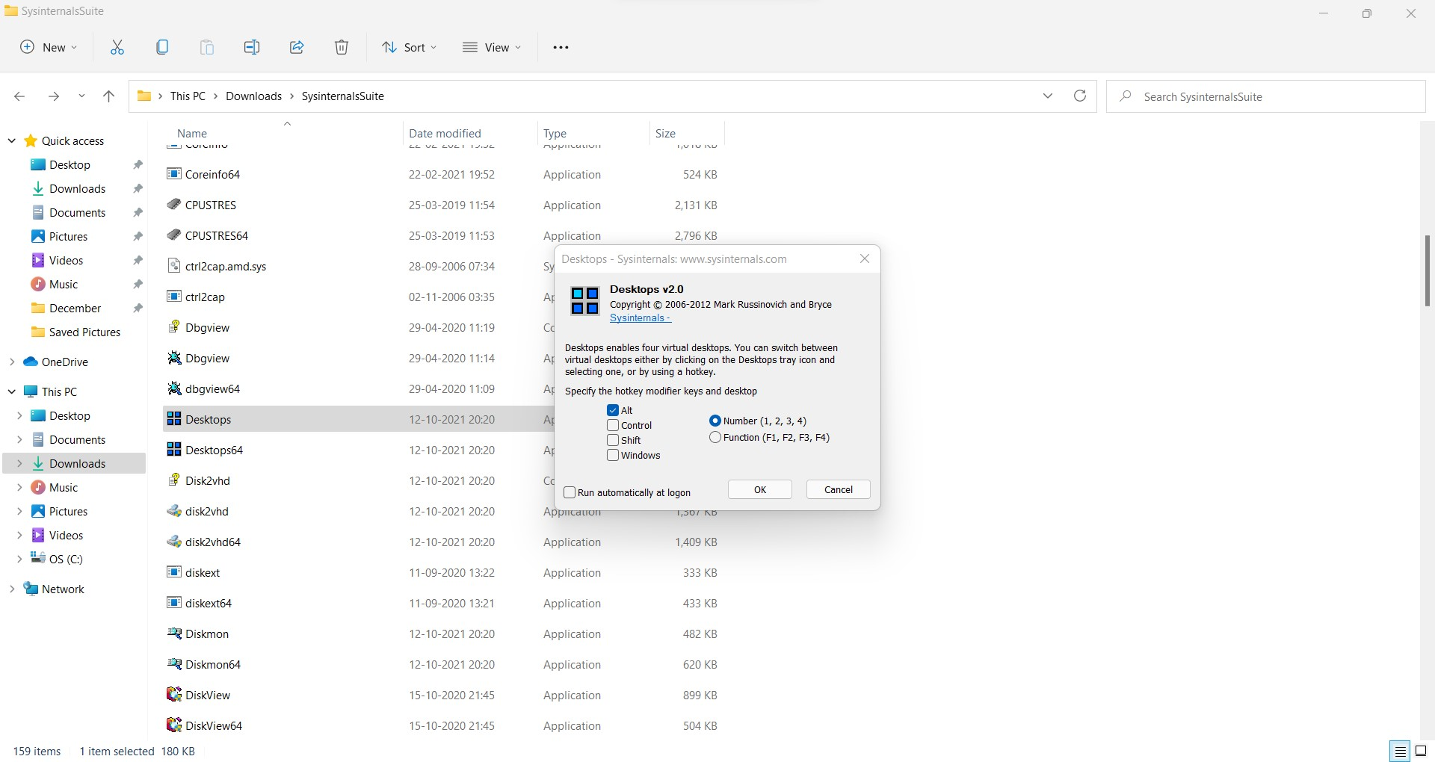Desktops - Helps to create four virtual desktops.

[Disk2vhd](https://docs.microsoft.com/en-us/sysinternals/downloads/disk2vhd) – It simplifies and displays the migration of physical systems into virtual machines.

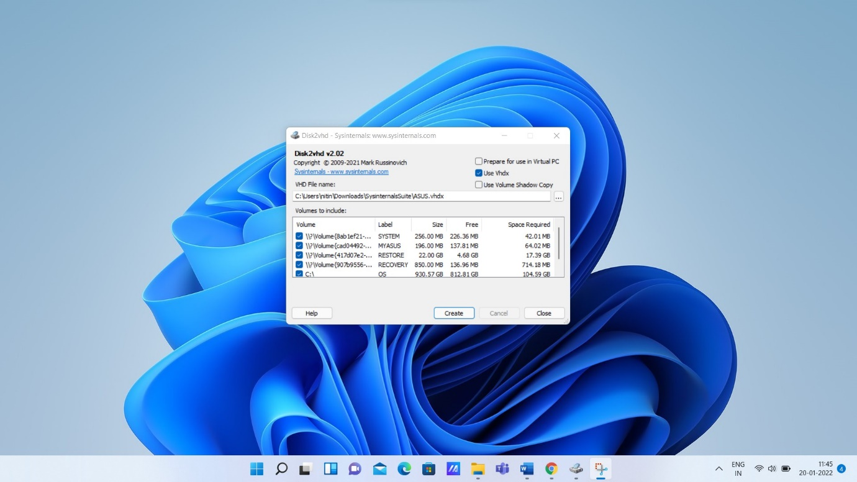

[DiskView](https://docs.microsoft.com/en-us/sysinternals/downloads/diskview) - Graphical disk sector utility.

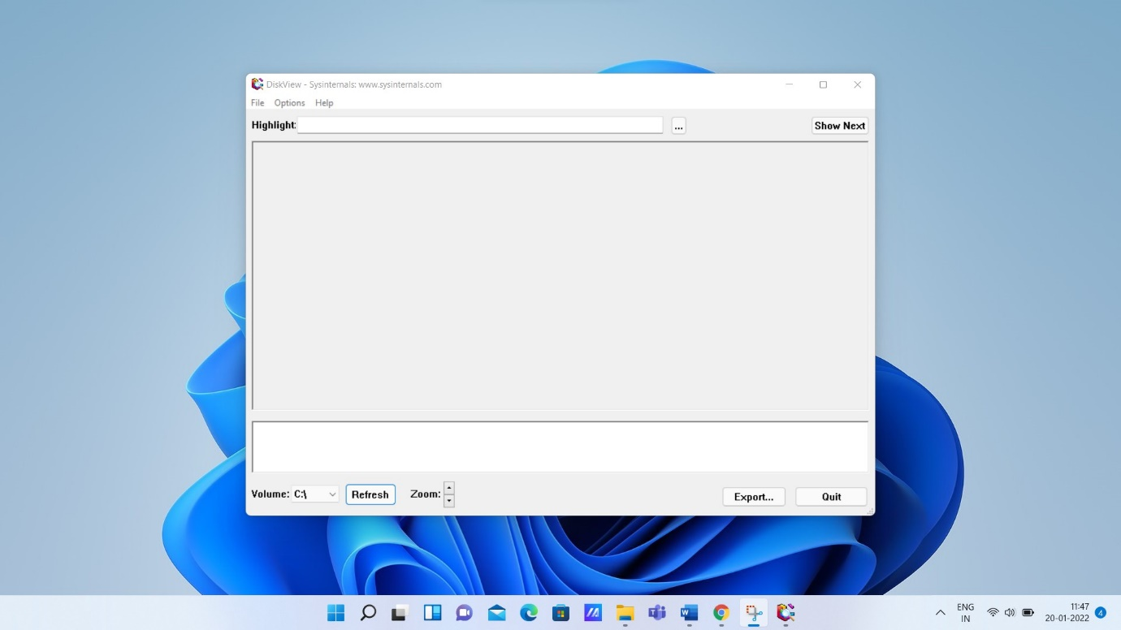

[LoadOrder](https://docs.microsoft.com/en-us/sysinternals/downloads/loadorder) – Displays the order in which devices are loaded on system.

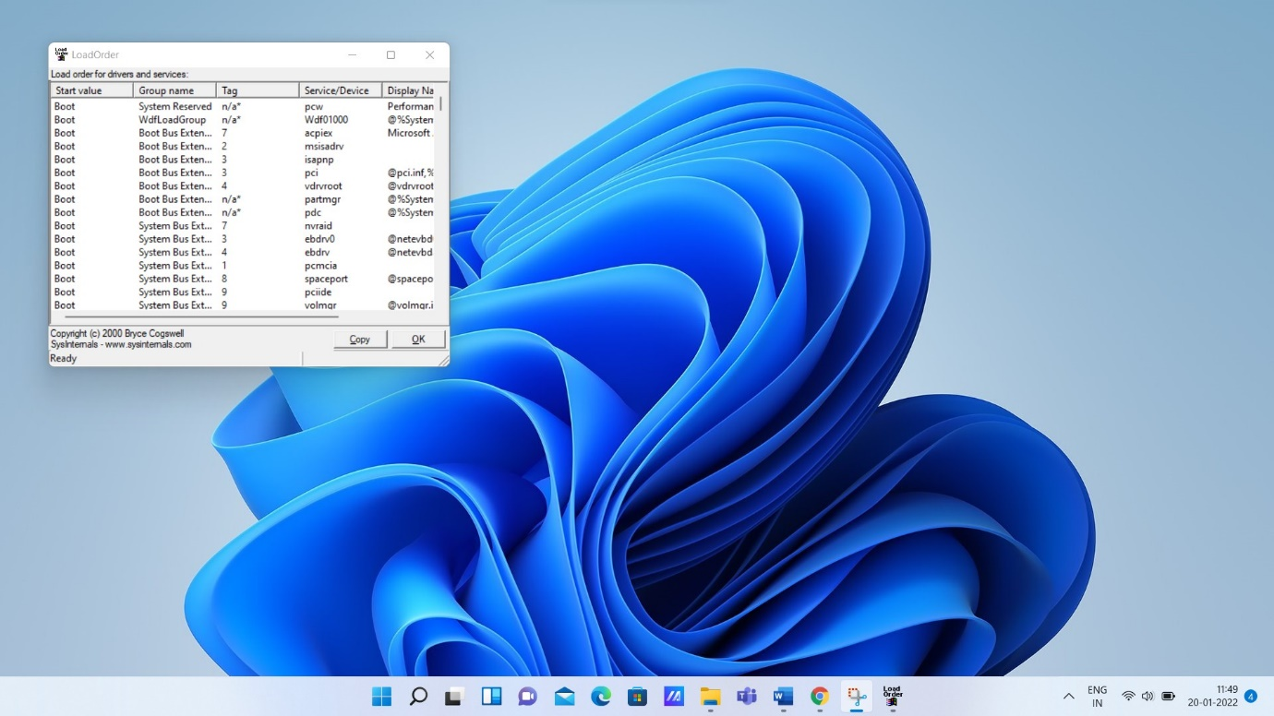

[Process Explorer](https://docs.microsoft.com/en-us/sysinternals/downloads/process-explorer) - Find out what files, registry keys and other objects processes have open, which DLLs they have loaded, and more.

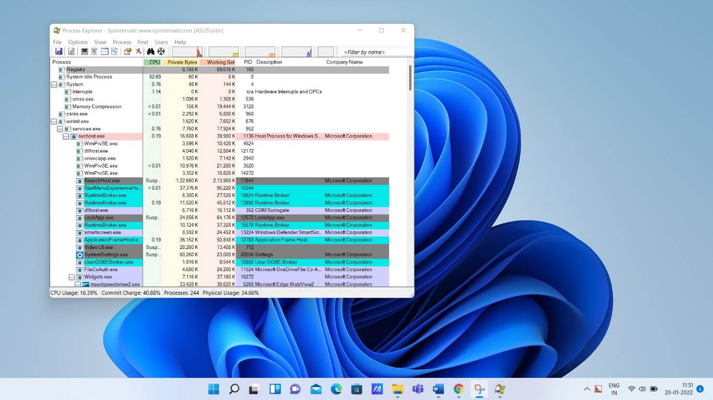

[Process Monitor](https://docs.microsoft.com/en-us/sysinternals/downloads/procmon) - Monitors file system, Registry, process, thread and DLL activity in real-time.

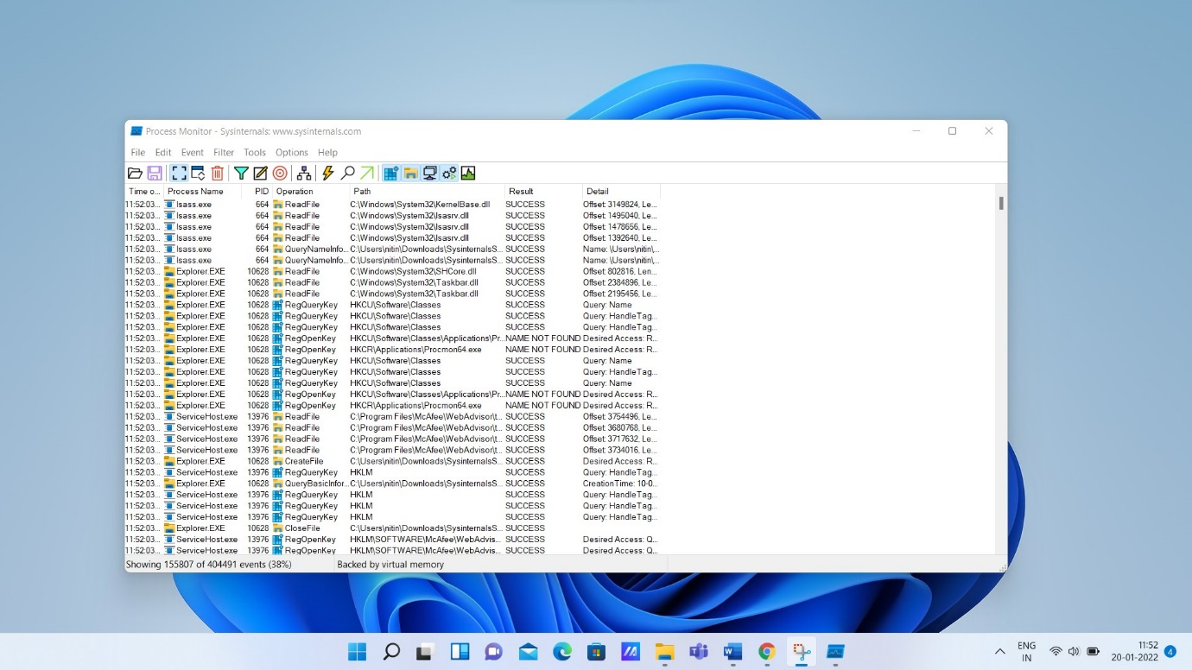

[RAMMap](https://docs.microsoft.com/en-us/sysinternals/downloads/rammap) - An advanced physical memory usage analysis utility that presents usage information in different ways on its several different tabs.

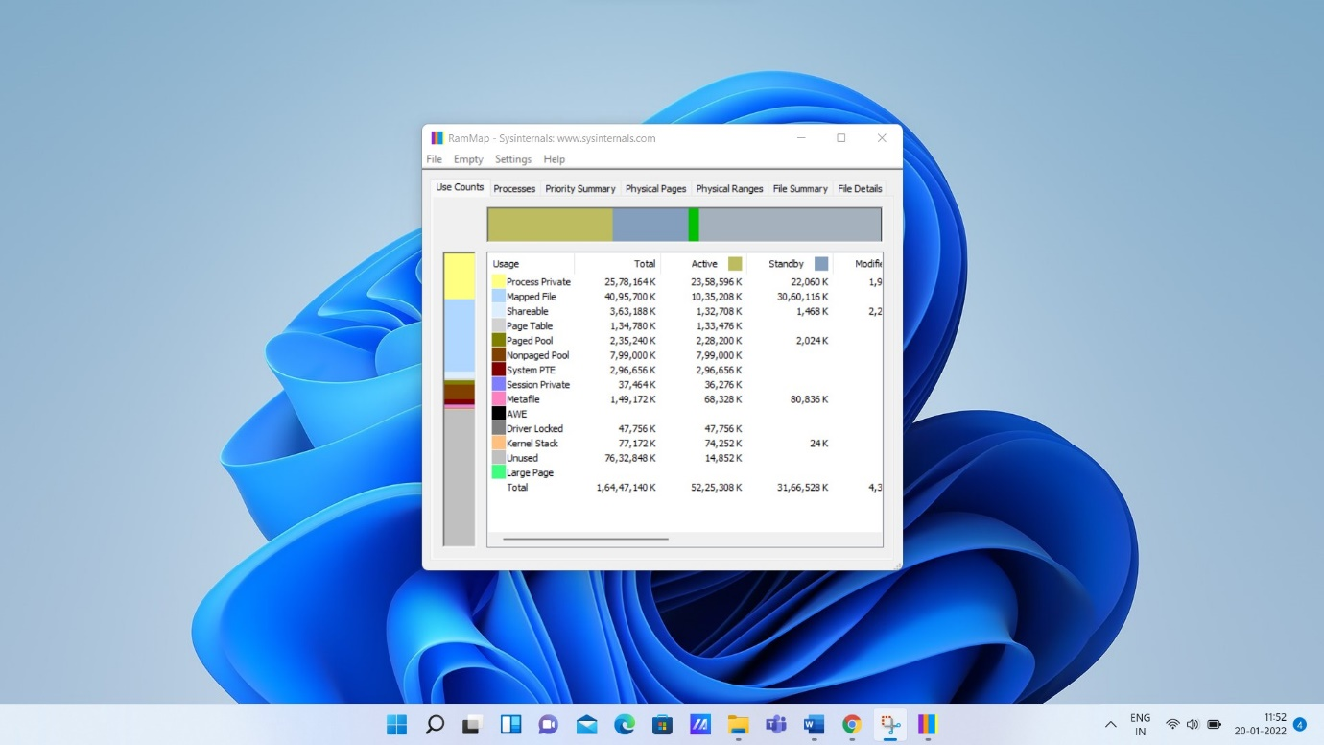

[ShareEnum](https://docs.microsoft.com/en-us/sysinternals/downloads/shareenum) - Scan file shares on your network and view their security settings to close security holes.

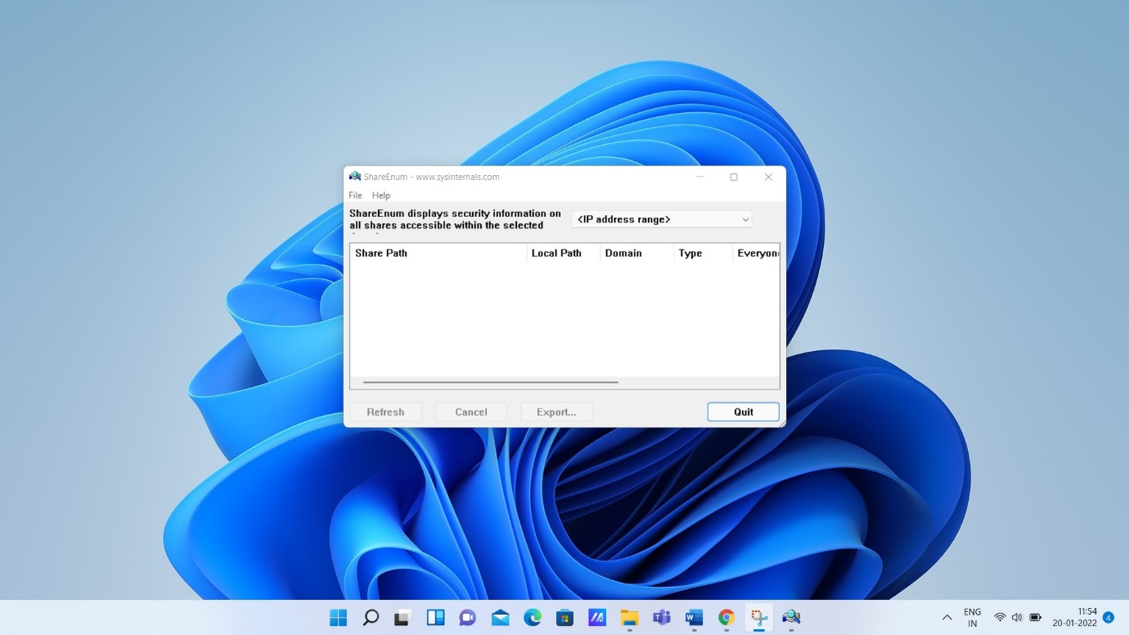

[ShellRunas](https://docs.microsoft.com/en-us/sysinternals/downloads/shellrunas) - Launch programs as a different user via a convenient shell context-menu entry.

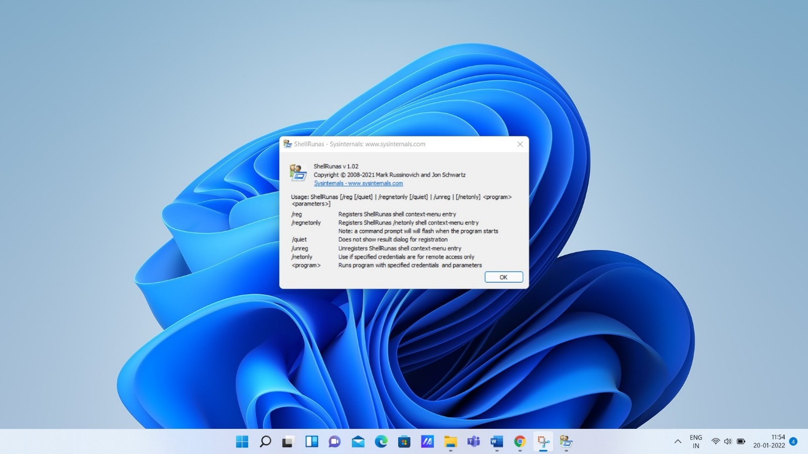

[TCPView](https://docs.microsoft.com/en-us/sysinternals/downloads/tcpview) – Displays the active socket.

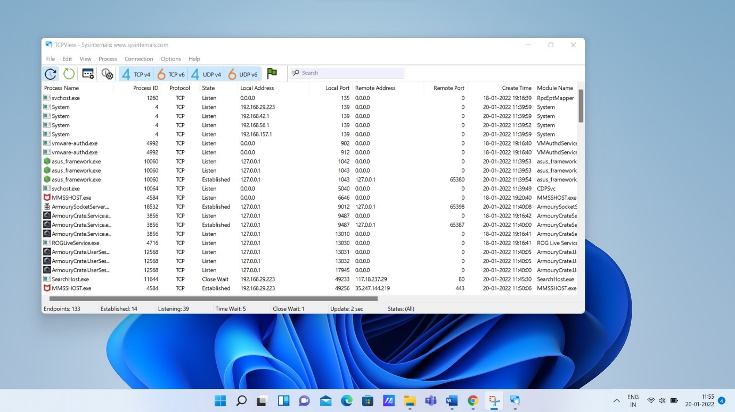

[VMMap](https://docs.microsoft.com/en-us/sysinternals/downloads/vmmap) - VMMap is a process virtual and physical memory analysis utility.

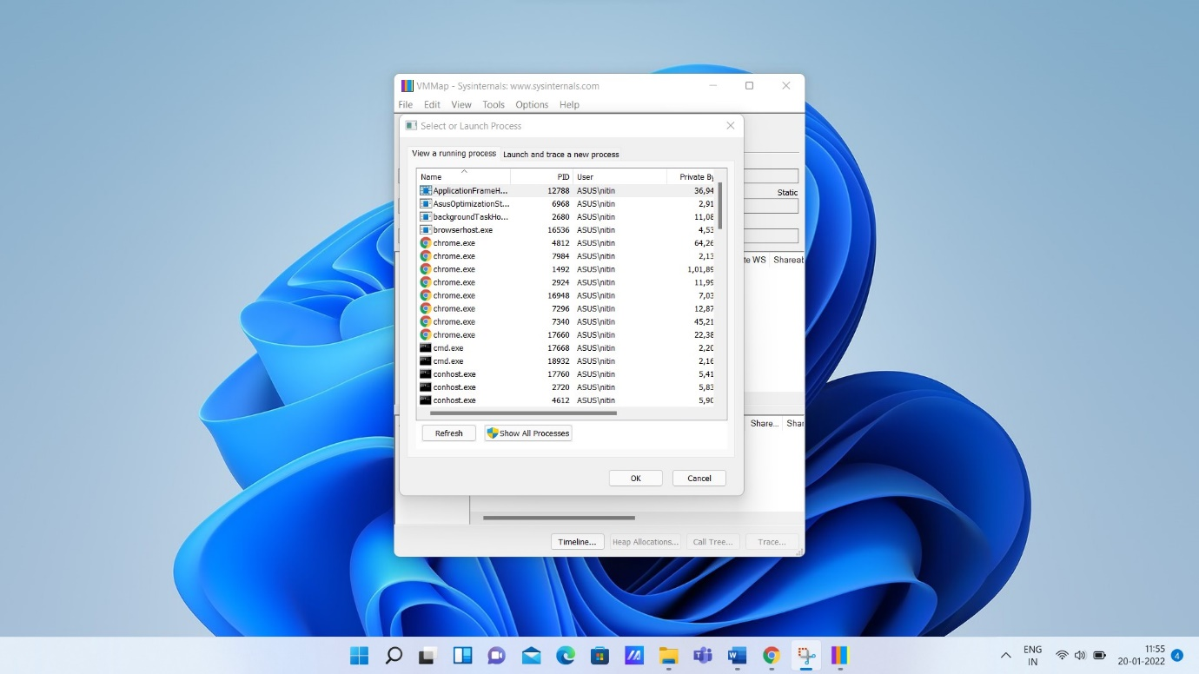

[WinObj](https://docs.microsoft.com/en-us/sysinternals/downloads/winobj) – Shows the object manager namespace viewer.

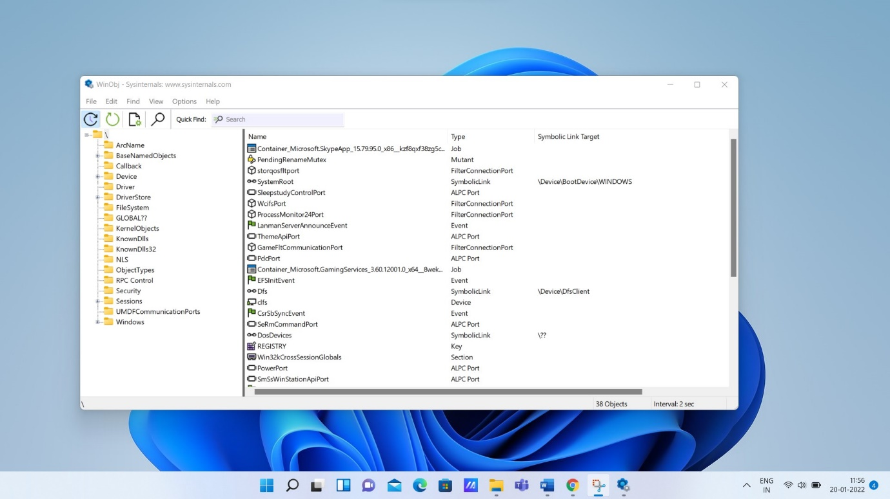

[ZoomIt](https://docs.microsoft.com/en-us/sysinternals/downloads/zoomit) – Used for zooming and drawing on the screen.

